
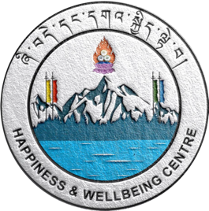

What is Self-Care

Self-care is all about making a continuous decision to
prioritize and look after your mental, physical,
emotional and spiritual wellbeing.

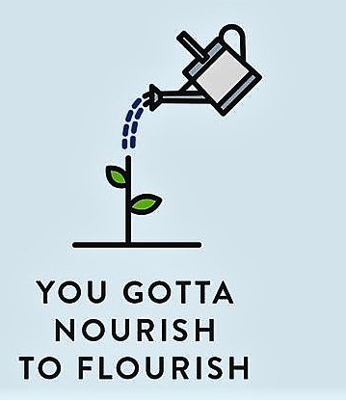
Why Self- Care
Self-care encourages you to maintain a healthy relationship with yourself so that you can transmit the good feelings to others. You cannot give to others what you don't have yourself.

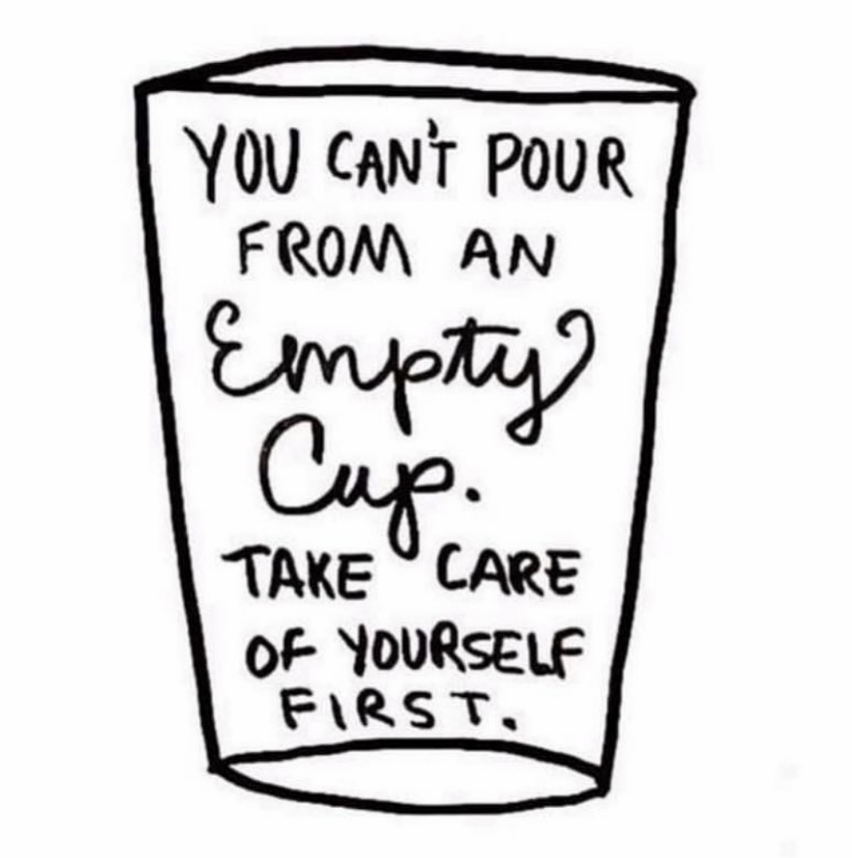

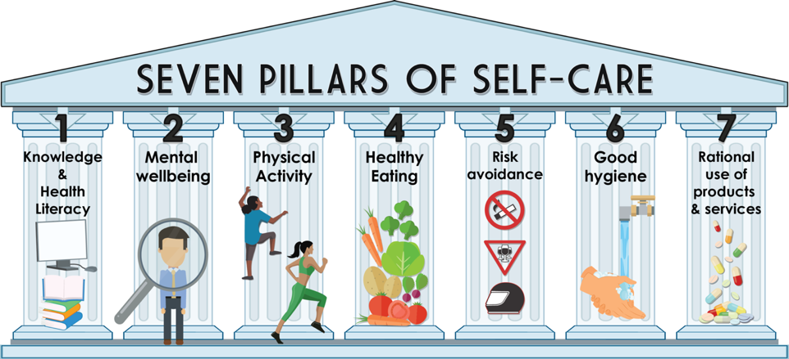

Remember to INCLUDE ALL THE FOUR DIMENSIONs OF SELF-CARE (See below) in your Self-Care Plan.

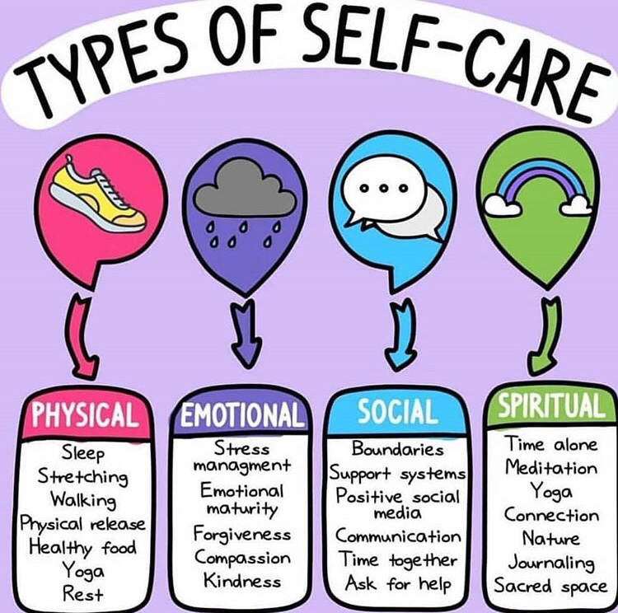

How to look after yourself?
Take a minute to examine where you are at in
the pillars of self-care and work on the pillars
that need more attention. Develop a self-care
plan for yourself and put it in action.
The plan can be in the form of daily
routine, weekly or forth nightly goal.
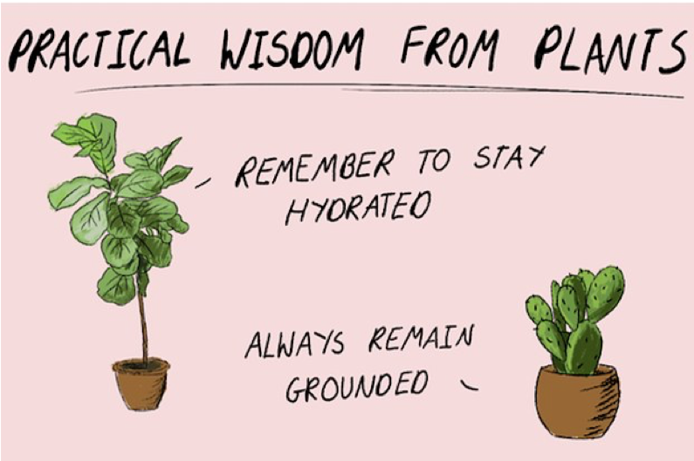

For more assistance on self-care, contact the Happiness and Wellbeing Centre at:

Centre Manager:
Mr. Shah Bir Rai (DSA) +975 17349214
shahbirrai.jnec@rub.edu.bt
Counsellor: wellbeing Coach (SSO)
Ms.Phurpa Dema Mr. Phub Tshering (SSO) +97517370679
(SSO) +975 17258251 phubtshering.jnec@rub.edu.bt
phurpdema.jnec@rub.edu.bt

https://jnec.emcwub.pce.edu.bt

