
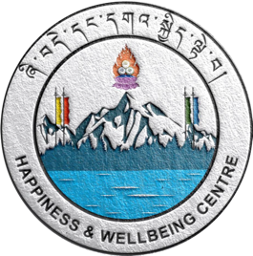
Mindfulness is a skill
Happiness and Wellbeing Centre
Mindfulness
Mindfulness


Learning to meditate is like learning any other skill.
Think of it like exercising a muscle that you’ve never
really worked out before. It takes consistent practice
to get comfortable. And it’s usually easier if you
have a teacher.
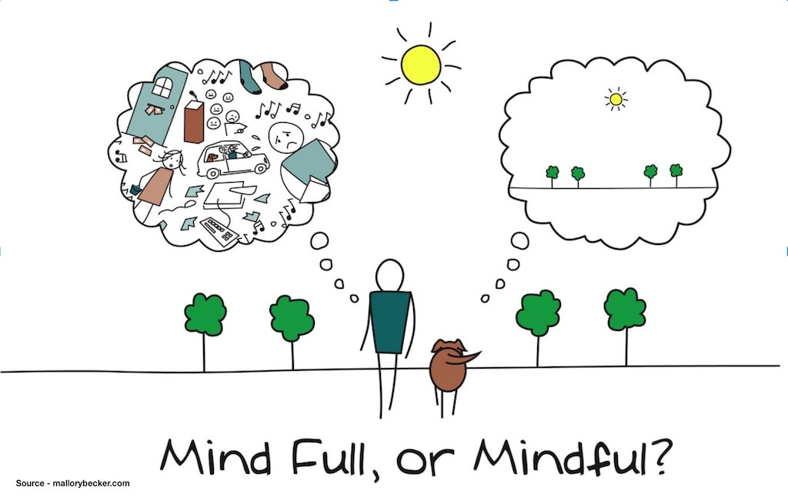
What is Mindfulness?
Mindfulness is the ability to be present, to rest in the here
and now, fully engaged with whatever we’re doing in the
moment.

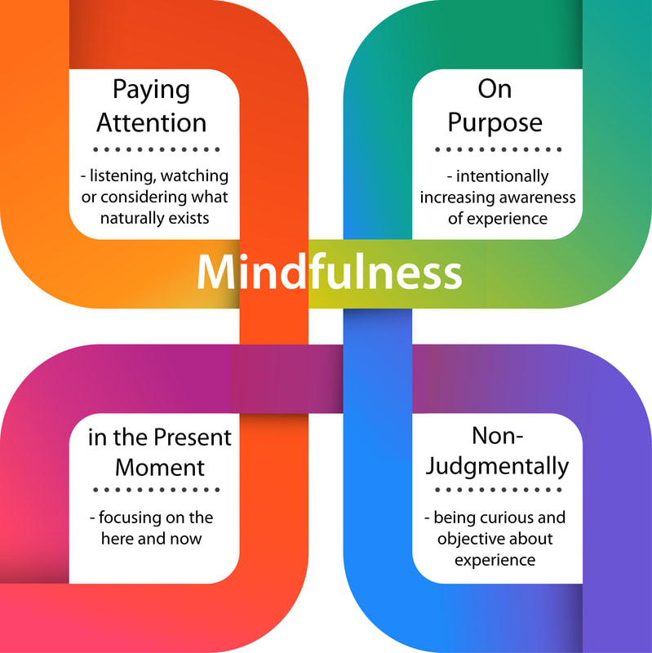

The benefits of mindfulness
People who incorporate it into their lives
often report heightened levels of happiness,
patience, acceptance, and compassion, as
well as lower levels of stress, frustration,
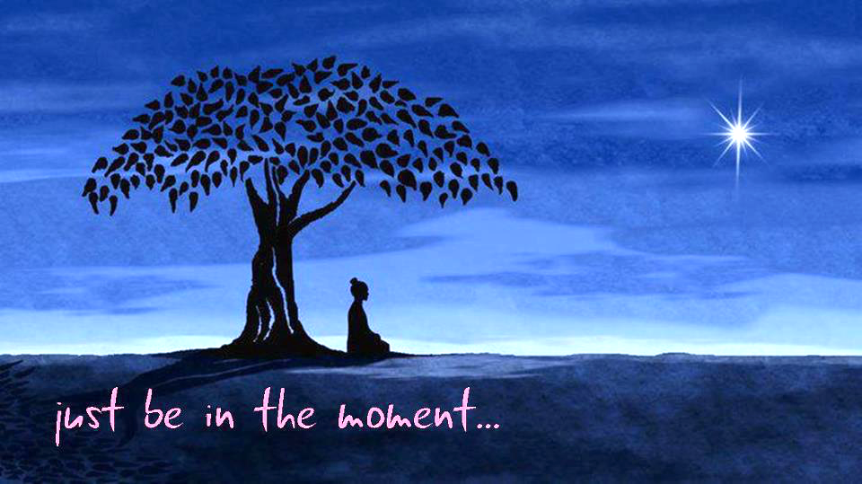
and sadness.
8 meditation techniques that cultivate mindfulness
(https://www.headspace.com/mindfulness)
Pick one or two techniques and try it RIGHT NOW!

1. Focused Attention: Likely the most common form of meditation, this technique uses the breath to anchor the mind and maintain awareness. Focus your attention on the breath — specifically the rise and fall of the chest — and return to the breath whenever youget distracted or notice your mind starting to wander.

2. Body Scan: This technique, which uses meditation to connect with the body, involves scanning your body from head to toe and being aware of any discomfort, sensations, or aches that exist (which could be indicators of stress and anxiety).

3. Noting: This is a mindfulness technique in which you “note” a particular thought or feeling when you become distracted during meditation.

4. Loving Kindness: Instead of focusing on the breath, this technique involves focusing on the image of different people: people we know, people we don’t; people we like, people we don’t. We direct well-wishes and goodwill first to ourselves, and then, as a ripple effect, to others, which helps us let go of unhappy feelings we may be experiencing.

5. Skillful Compassion: Similar to the loving kindness meditation technique, this one involves focusing on a person you know or love and paying attention to the sensations arising from the heart.
6. Visualization: This technique uses visualization, to focus on a person or something more abstract, to hold attention. The idea here is that the familiar image will help create and maintain a relaxed focus.
7. Resting Awareness: Rather than focusing on the breath or a visualization, this technique involves letting the mind rest; thoughts may enter, but instead of distracting you and pulling you away from the present moment, they simply leave.
8. Reflection: For this technique, ask yourself a question, for example, “What are you most grateful for?” ‘What are my strengths and weaknesses?’, ‘What is the purpose of life? Etc.

For more support on Mindfulness Practice contact the Happiness and Wellbeing Centre at:

Centre Manager:
Mr. Shah Bir Rai (DSA) +975 17349214
shahbirrai.jnec@rub.edu.bt
Counsellor: wellbeing Coach (SSO)
Ms.Phurpa Dema Mr. Phub Tshering (SSO) +97517370679
(SSO) +975 17258251 phubtshering.jnec@rub.edu.bt
phurpdema.jnec@rub.edu.bt

https://jnec.emcwub.pce.edu.bt

